# Etape 1 :

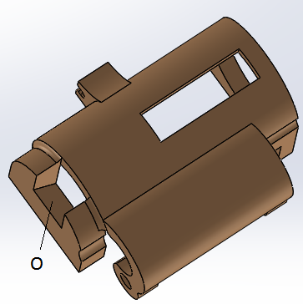

Glue with cyanoacrylate, mirror in O. Do not put fingerprints on the mirror.

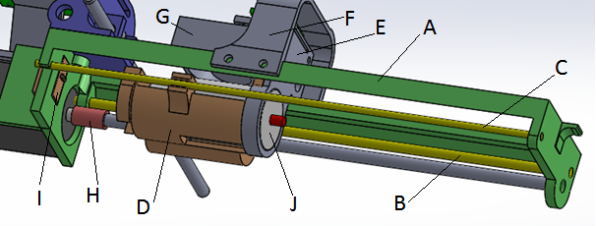

Fit A, B, C, D together without at the moment gluing C and B to A.

Adjust the position and the parallelism of the axes B and C so that the carriage D slides from one end to the other of the piece A. The carriage D must slide without hard point.

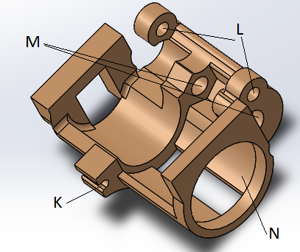

If necessary, file the holes L and the groove K so that the sliding is softer.

Attention, do not have too many games in the grove K and L.

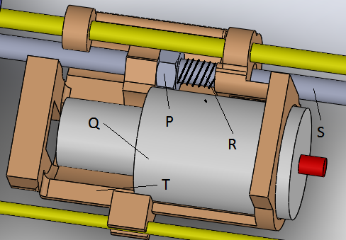

Fit P, R and S on part T. Do not glue the nut P. It should just not turn.

Adjust the focal point of the Laser lens so that the laser dot is about 25mm from the laser output.

Mount the laser on piece T. It must go into abutment with T.

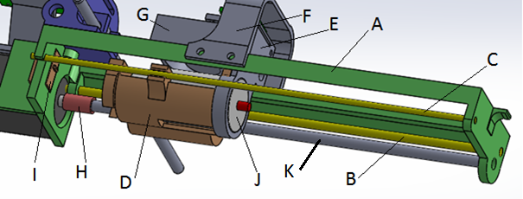

Adjust the diameter of H by successively inserting rods of 3mm, 3.5mm and 4mm and heating H. This makes it possible to increase the inside diameter of H so that it can be inserted on K and on the motor axis.

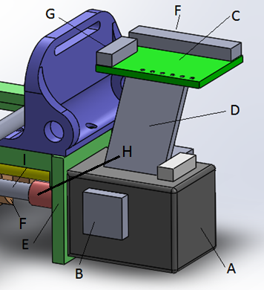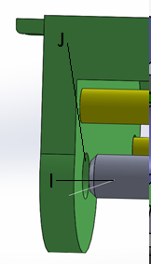

Fix H on I and A. The laser support F must be at the ready of motor A. Position motor A on workpiece E. Make sure that motor A is correctly centered with axis I and carriage F which supports the laser. Motor A is centered if the end of the threaded rod I is centered on J.

As soon as the motor is centered, keep it firmly in position and glue it with hot glue on E.

Check that the carriage F moves well over its entire stroke.

Glue D to A and C to D. Glue B to A. Piece B must be positioned to press switch Y. Hot glue must be used.

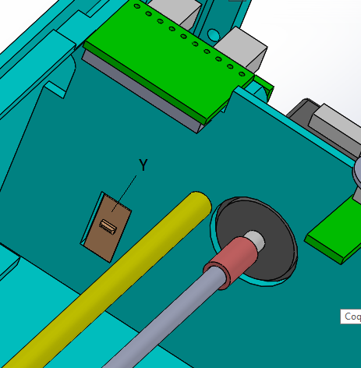

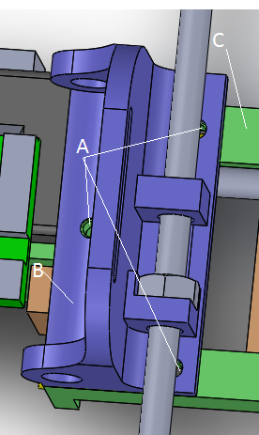

Fix B on C with M2x6mm screws

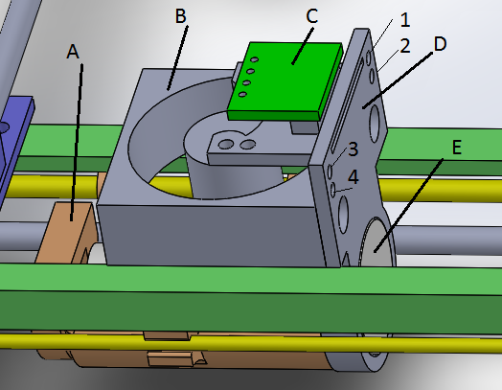

Paste D on A and E.

Paste B on D.

Pass the cables from B through 3 and 4 and solder them on C.

Pass the E cables through 1 and 2 and solder them on C.



Paste I on A.

Paste F on A, in the middle of A.

This very important first step is over.

It must be ensured that the carriage moves very well while operating the motor.

# Etape B

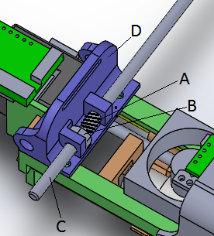

Insert spring A, nut B and threaded rod 130mm C into piece D.

Do not stick B to D.

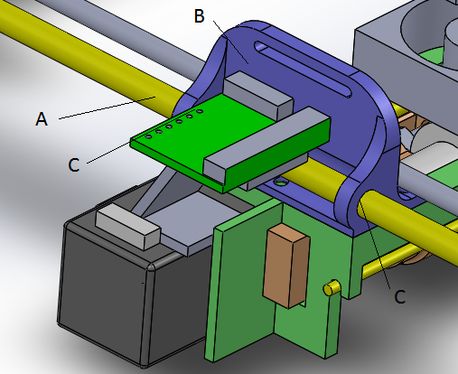

Adjust the holes C in B, so that the axis A slides freely without games.

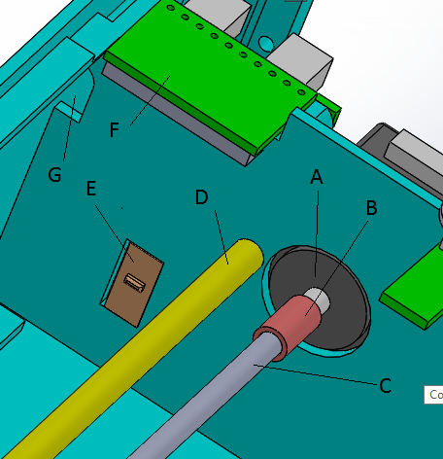

As with the other motor-axle coupling, adjust B to adjust to C and A. When motor A rotates, the C-axis should rotate without moving vertically and horizontally.

Paste E.

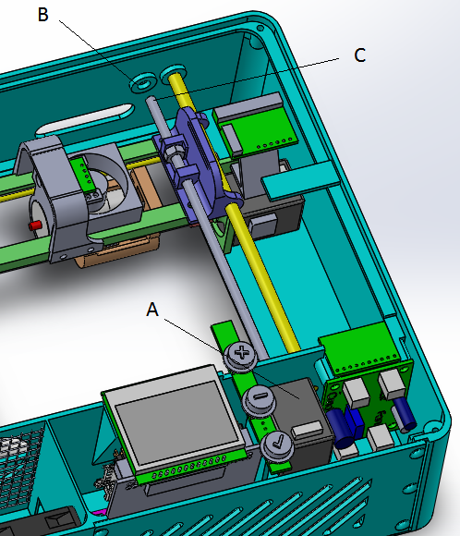

Adjust the position of A so that C is centered on B. Glue A to the hot glue.

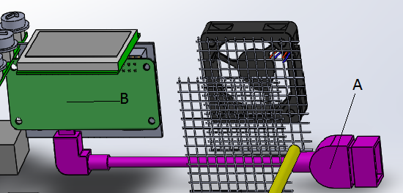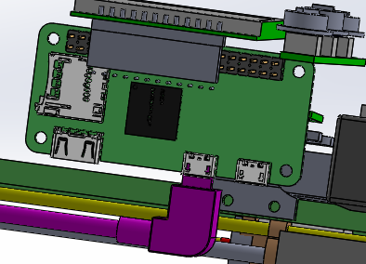

Fix the cable A on the Raspberry Pi

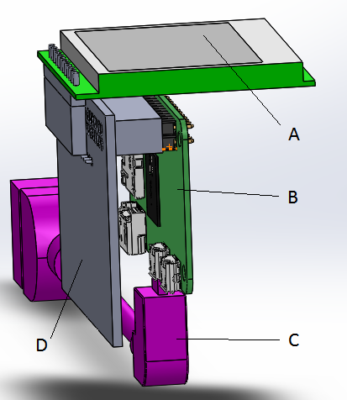

Attach Screen A to the D card and Raspberry PI B.

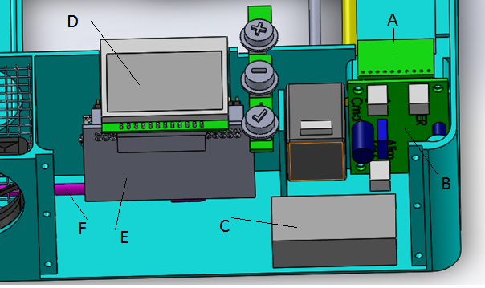

Glue A, C, E, D to the hot glue.

Screw B.

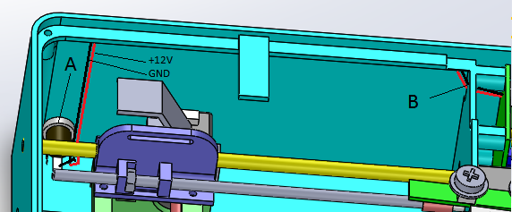

Fix A and pass the cables at the top of the box until B

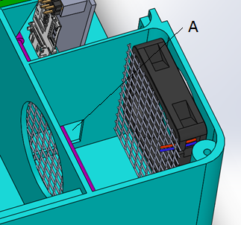

Glue the grids and the fan to the hot glue.

Block the passage of the cable.

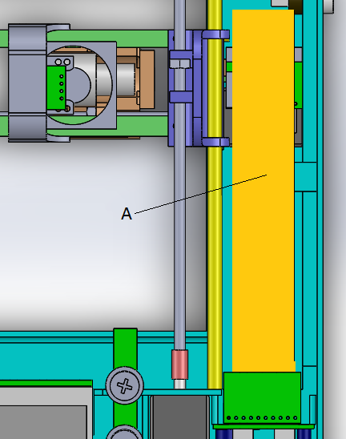

Fix the tablecloth A

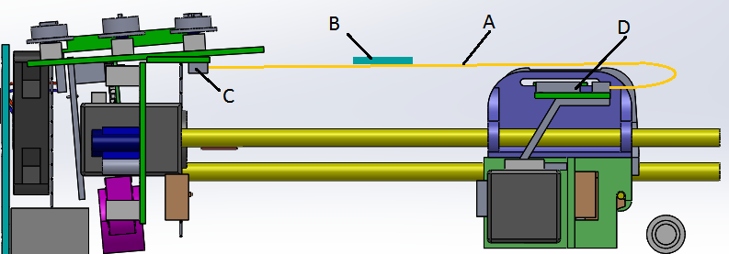

Fix the tablecloth A on the card C and D. Stick the tablecloth A on B.

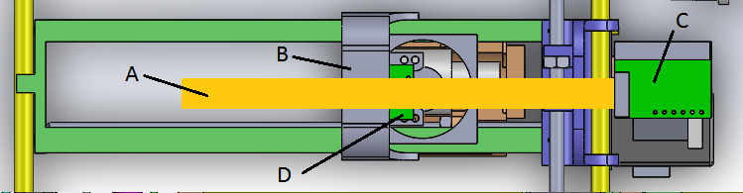

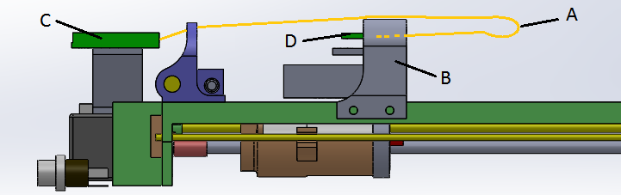

Fix the tablecloth A on C and D. Stick A on B.

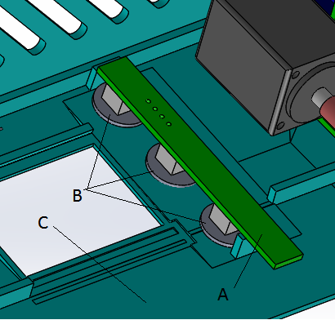

Fix the button board with the +, - and val buttons on the cover C.